LEVEL 1 (EASY)

1. What is MySQL?

MySQL is a multithreaded, multi-user SQL database management system which has more than 11 million installations. It is the world's second most popular and widely-used open source database. It is interesting how MySQL name was given to this query language. The term My is coined by the name of the daughter of co-founder Michael Widenius's daughter, and SQL is the short form of Structured Query Language. Using MySQL is free of cost for the developer, but enterprises have to pay a license fee to Oracle.

1. Why do we use the MySQL database server?

First of all, the MYSQL server is free to use for developers and small enterprises.

* MySQL server is open source.
* MySQL's community is tremendous and supportive; hence any help regarding MySQL is resolved as soon as possible.
* MySQL has very stable versions available, as MySQL has been in the market for a long time. All bugs arising in the previous builds have been continuously removed, and a very stable version is provided after every update.

1. How to add columns in MySQL?

A column is a series of cells in a table that stores one value for each row in a table. We can add columns in an existing table using the ALTER TABLE statement as follows:

ALTER TABLE table_name

ADD COLUMN column_name column_definition [FIRST|AFTER existing_column];

1. How to delete a table in MySQL?

We can delete a table in MySQL using the Drop Table statement. This statement removes the complete data of a table, including structure and definition from the database permanently. Therefore, it is required to be careful while deleting a table. After using the statement, we cannot recover the table in MySQL.

DROP TABLE  table_name;

1. Create a database: command used to create a database.

create database database_name;

1. drop database table:

DROP statement used to delete tables in the database.

DROP DATABASE database_name;

1. how to rename the database name?

SQL RENAME DATABASE used to change the name of your database.

Query:

RENAME DATABASE old_database_name TO new_database_name;

1. how to create SQL a table?

A table creation command requires three things:

* Name of the table
* Names of the fields
* Definitions for each field

CREATE TABLE employee(

id int primary key NOT NULL auto_increment,

name varchar(20) NOT NULL,

occupation varchar(20) NOT NULL,

age int NOT NULL,

);

1. how to SQL Insert values ?

Insert statement is used to insert values inside the tables.

1. how to UPDATE statement?

It used to update the records of the database table.

UPDATE `employee` SET age = 22 where id= 2

1. how to delete records in SQL?

Delete statement is used to delete the specific records of the table.

DELETE FROM `employee` WHERE id = 4;

1. how to delete all records in table?

Truncate is used to delete all the data from the table.

TRUNCATE TABLE table_name;

1. how to use AND and OR operator?

The AND Operator

The SQL AND condition is used in SQL query to create two or more conditions to be met.

SELECT * FROM `employee` where age = 21 and id = 1

The OR operator:

The SQL OR condition is used in a SQL query to create a SQL statement where records are returned when any one of the condition met. It can be used in a SELECT statement, INSERT statement, UPDATE statement or DELETE statement.

SELECT * FROM `employee` WHERE age=24 or name = 'jhon';

Combining AND & OR Operator

You can also combine AND and OR statements together.

SELECT * FROM employee WHERE age > 20 AND (id = 1 OR id = 3)

1. What is the use of ORDER BY?

The SQL ORDER BY statement used to sort the data in ascending or descending order.

SELECT * FROM employee ORDER BY age ASC;

SELECT * FROM employee ORDER BY age desc;

1. What is the use of SQL DISTINCT?

SQL DISTINCT keyword used to fetch unique records.

SELECT DISTINCT age FROM employee;

1. How to alter alter table?

MySQL ALTER statement is to change the name of your table or any table. It used to add or delete an existing table.

1. ADD column:

ALTER TABLE employee ADD dept varchar(20);

1. DROP column:

ALTER TABLE employee DROP COLUMN dept;

1. MODIFY column:

ALTER TABLE employee MODIFY COLUMN age bigint;

1. SQL Aggregate Functions
2. Explain MYSQL aggregate functions?

SQL aggregate functions used to calculate values in a column.

1. Max(): is used to find the largest value in a table.

SELECT max(age) FROM employee;

1. Min(): is used to find the smallest value in a table.

SELECT min(age) FROM employee;

1. Avg(): is used to find average value in a table.

SELECT avg(age) FROM employee;

1. Sum(): is used to find the total in a table.

SELECT sum(age) FROM employee;

1. Count(): is used to total count in a table.

SELECT count(age) FROM employee;

1. Explain MYSQL joins?

The SQL Joins clause used to combine two or more tables in a database

Different Types of SQL Joins

Different types of the JOINs in SQL:

1. (INNER) JOIN: Returns matching values in both tables.
2. LEFT (OUTER) JOIN: Return all records from the left table, and matching data of the right table.
3. RIGHT (OUTER) JOIN: Return all records from the right table, and matching data of the left table.
4. FULL (OUTER) JOIN: Return all records when there is a match in either left or the right table.
5. What is Database Testing? Please give an example?

It is AKA back-end testing or data testing. Database testing involves in verifying the integrity of data in the front end with the data present in the back end. It involves in updating records in a database and verifying the same on the front end.

1. Explain SQL Data Types? Please give an example?

In SQL Server, each column in a database table has a name and a data type. We need to decide what type of data to store inside each and every column of a table while creating a SQL table. There are many different Data Types,

the common are: Numbers – 1234 VarChar2 - String, letters,

characters (Variable Length) Char - String, letters, characters (Fixed Length)

Date - 02/13/201 Difference between Char() and varChar2()in Memory Allocation

1. What is a GROUP BY Clause? Have you use it? Please give an example?

The GROUP BY statement is often used with aggregate functions (COUNT, MAX, MIN, SUM, AVG) to group the result-set by one or more columns.

SELECT COUNT(*), DEPARTMENT_ID FROM EMPLOYEES WHERE DEPARTMENT_ID IN(10,50,80,100,110,120,150) GROUP BY DEPARTMENT_ID HAVING COUNT(*)>5;

1. How can you get first 5 records from the Table? Last 5 records?

Please give an example For that we can use

ROWNUM Keyword: SELECT EMPLOYEE_ID, FIRST_NAME FROM EMPLOYEES WHERE ROWNUM<=5 ORDER BY EMPLOYEE_ID;

SELECT EMPLOYEE_ID, FIRST_NAME FROM EMPLOYEES WHERE ROWNUM<=5 ORDER BY 1 DESC;

1. What is Database Testing? Please give an example?

It is AKA back-end testing or data testing. Database testing involves in verifying the integrity of data in the front end with the data present in the back end. It involves in updating records in a database and verifying the same on the front end.

LEVEL 2 (intermediate)

1. What is difference between DELETE and TRUNCATE?

Please give an example DELETE: delete selected rows from the table, WHERE clause can be used for conditional parameters. Deleted records can be rolled back or committed. TRUNCATE: delete ALL rows from the table >> auto-commits, i.e. cannot be rolled back.

DELETE FROM INSURANCE WHERE POLICY_NUMBER=0002;

TRUNCATE TABLE JOB_HISTORY;

1. What is the difference between UNION and UNION ALL?

give an example UNION merges the contents of two structurally-compatible tables into a single combined table. UNION will omit duplicate records whereas and it will also sort the results where is UNION ALL will include duplicate records. The performance of UNION ALL will typically be better than UNION, since UNION requires the server to do the additional work of removing any duplicates.

SELECT FIRST_NAME, LAST_NAME, EMAIL FROM EMPLOYEES UNION ALL SELECT FIRST_NAME, LAST_NAME, EMAIL FROM MY_TABLE;

SELECT FIRST_NAME FROM EMPLOYEES UNION SELECT LAST_NAME FROM EMPLOYEES;

1. What is the difference between BETWEEN and IN condition operators? Please give an example ?

BETWEEN: used to display rows based on a range of values IN: used to check for values contained in a specific set of values.

SELECT * FROM EMPLOYEES WHERE SALARY IN (6000, 10000); SELECT * FROM EMPLOYEES WHERE SALARY BETWEEN 6000 AND 10000;

1. What is the difference between the WHERE and HAVING clauses? Please give an example

The WHERE clause is used to filter records from a result. The filtering occurs before any groupings are made. The HAVING clause is used to filter values from a group (i.e., to check conditions after aggregation into groups has been performed.

SELECT COUNT(*), DEPARTMENT_ID FROM EMPLOYEES WHERE DEPARTMENT_ID IN(10,50,80,100,110,120,150) GROUP BY DEPARTMENT_ID HAVING COUNT(*)>5;

1. What is the difference between an inner and outer join? Please give an example?

An inner join returns rows when there is at least some matching data between two (or more) tables that are being compared. An outer join returns rows from both tables that include the records that are unmatched from one or both the tables.

SELECT COUNT(EMPLOYEE_ID), E.DEPARTMENT_ID, DEPARTMENT_NAME FROM EMPLOYEES E INNER JOIN DEPARTMENTS D ON E.DEPARTMENT_ID=D.DEPARTMENT_ID GROUP BY E.DEPARTMENT_ID, DEPARTMENT_NAME;

SELECT COUNT(EMPLOYEE_ID), E.DEPARTMENT_ID, DEPARTMENT_NAME FROM EMPLOYEES E FULL OUTER JOIN DEPARTMENTS D ON E.DEPARTMENT_ID=D.DEPARTMENT_ID GROUP BY E.DEPARTMENT_ID, DEPARTMENT_NAME;

1. What is the difference between Commit and Rollback? Please write an example?

both ROLLBACK and COMMIT Commands are TCC (Transaction Control Commands), they have differences: COMMIT is used to save the changes permanently on the server ROLLBACK is used to undo the changes and restore previous state.

1. Which Operators available in SQL? Please give an example?

SQL Operator is a reserved word used primarily in an SQL statement’s WHERE clause to perform operations, such as arithmetic operations and comparisons.

These are used to specify conditions in an SQL statement. There are three types of Operators. 1. Arithmetic Operators

SELECT FIRST_NAME, LAST_NAME, SALARY*12 FROM EMPLOYEES;

1. Comparison Operators SELECT FIRST_NAME, LAST_NAME, DEPARTMENT_ID FROM EMPLOYEES WHERE DEPARTMENT_ID = 90;
2. Logical Operators SELECT FIRST_NAME, LAST_NAME, SALARY FROM EMPLOYEES WHERE DEPARTMENT_ID = 90 AND LAST_NAME='King';

SELECT FIRST_NAME, LAST_NAME, SALARY FROM EMPLOYEES WHERE DEPARTMENT_ID = 90 OR LAST_NAME='King';

SELECT FIRST_NAME, LAST_NAME, DEPARTMENT_ID FROM EMPLOYEES WHERE DEPARTMENT_ID IN (90,100,110,10);

LEVEL 3 (DIFFICULT)

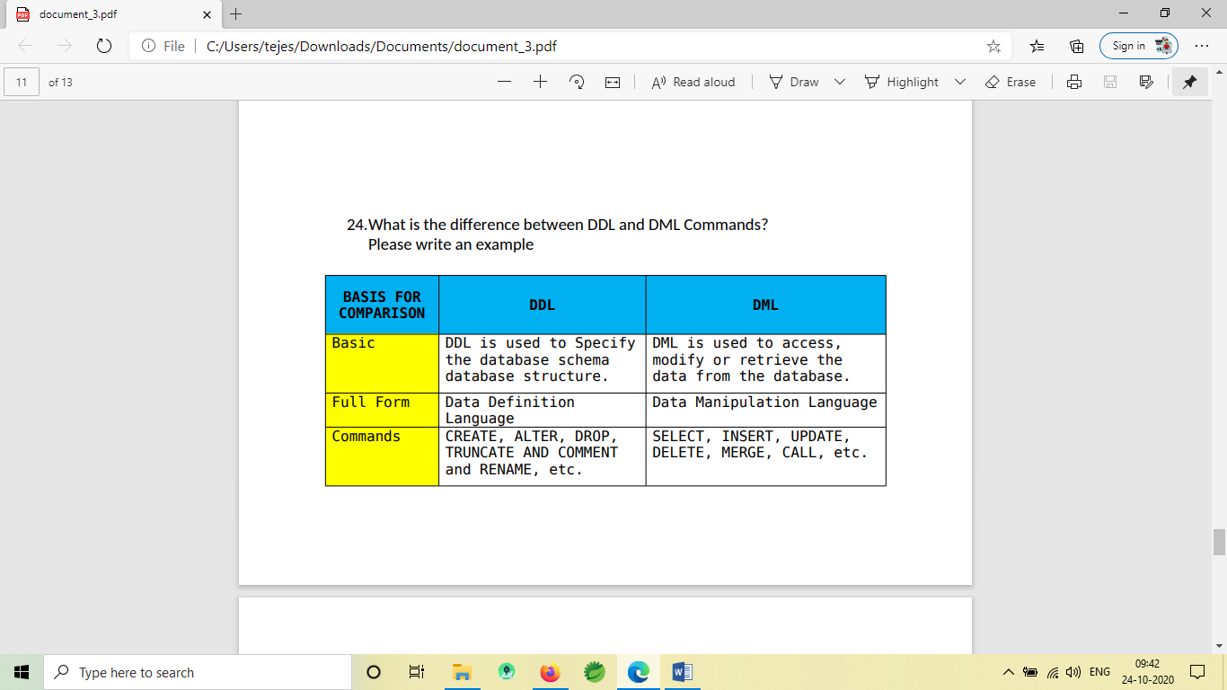

1. Let’s say you working on a Employees Database.

How would you write a query to find out those employees whose first name starts with character ‘N’, ‘A’, ‘K’ ?

Please write an example

SELECT * FROM EMPLOYEES WHERE LAST_NAME LIKE 'A%'

UNION SELECT * FROM EMPLOYEES WHERE LAST_NAME LIKE 'N%'

UNION SELECT * FROM EMPLOYEES WHERE LAST_NAME LIKE 'K%';

Or SELECT * FROM EMPLOYEES WHERE LAST_NAME LIKE 'A%'

OR LAST_NAME LIKE 'N%' OR LAST_NAME LIKE 'K%';

1. Explain how would you query two or more tables when validating data in SQL Database?

Please give an example Using

Subquery: SELECT FIRST_NAME, LAST_NAME FROM EMPLOYEES WHERE DEPARTMENT_ID =( SELECT DEPARTMENT_ID FROM DEPARTMENTS WHERE DEPARTMENT_NAME ='Shipping');

Using JOINS SELECT EMPLOYEE_ID, FIRST_NAME, D.DEPARTMENT_ID, DEPARTMENT_NAME FROM EMPLOYEES E JOIN DEPARTMENTS D ON E.DEPARTMENT_ID=D.DEPARTMENT_ID;

1. How to write a query to show the details of employees from Employees table whose last names starts with K? Ends with k? Please write an example

To achieve that we can use LIKE Operator There are two wildcards used in conjunction with the LIKE operator: % - The percent sign represents zero, one, or multiple characters _ - The underscore represents a single character

SELECT * FROM EMPLOYEES WHERE LAST_NAME LIKE 'A%';

SELECT * FROM EMPLOYEES WHERE LAST_NAME LIKE '%a';

1. What is a Subquery ? Please give an example?

A Subquery is a SQL query within another query. It is a subset of a Select statement whose return values are used in filtering the conditions of the main query.

SELECT * FROM EMPLOYEES WHERE SALARY>(SELECT AVG(SALARY) FROM EMPLOYEES);

SELECT * FROM EMPLOYEES WHERE DEPARTMENT_ID IN (SELECT DEPARTMENT_ID FROM DEPARTMENTS WHERE DEPARTMENT_NAME LIKE 'A%');

1. What is the difference between primary key and candidate key?

To identify each row of a table, we will use a primary key. For a table, there exists only one primary key.

A candidate key is a column or a set of columns, which can be used to uniquely identify any record in the database without having to reference any other data.

1. What is the difference between mysql_connect and mysql_pconnect?

Mysql_connect() is used to open a new connection to the database, while mysql_pconnect() is used to open a persistent connection to the database. It specifies that each time the page is loaded, mysql_pconnect() does not open the database.

1. Can you tell what are the different set operations available in MySQL?

The various set operations available in MySQL are as follows:

* UNION – This operation returns all the distinct rows selected by a query
* UNION ALL – This operation returns all the rows selected by a query and also includes all duplicate rows.
* MINUS – This operation returns all the distinct rows selected by the first query but does not select the rows selected by the second query.
* INTERSECT – This operation returns all the distinct rows selected by both queries.

1. What is Normalization and list the different types of normalization?s

Normalization is the process of organizing data to avoid duplication and redundancy. There are many successive levels of normalization. These are called normal forms. Each consecutive normal form depends on the previous one. The first three normal forms are usually adequate.

* First Normal Form (1NF) – No repeating groups within rows
* Second Normal Form (2NF) – Every non-key (supporting) column value is dependent on the whole primary key.
* Third Normal Form (3NF) – Dependent solely on the primary key and no other non-key (supporting) column value.

1. Consider a scenario where you have two to three tables with thousand tuples in each of them. Now, if you have to perform a JOIN operation between them will you choose to perform filtering of rows or transforming of rows first.

The answer to this question is quite logical. If you have three tables with thousands of tuples in each of them, then you are first supposed to filter the rows in those tables and then transform the table. This would be beneficiary as if you transform the table, then the number of columns may increase reducing the performance. Due to such performance issues, a lot of memory will be used and the output will appear on your screen after quite a long wait of time.

1. What is the main difference between ‘BETWEEN’ and ‘IN’ condition operators?

BETWEEN operator is used to display rows based on a range of values in a row whereas the IN condition operator is used to check for values contained in a specific set of values.

Example of BETWEEN:

SELECT * FROM Students where ROLL_NO BETWEEN 10 AND 50;

Example of IN:

SELECT * FROM students where ROLL_NO IN (8,15,25);

1. What are the purposes of using ENUM and SET data types?

Answer: ENUM data type is used in the MySQL database table to select any one value from the predefined list.

The value of a particular field can be restricted by defining the predefined list as the field which is declared as ENUM will not accept any value outside the list.

The SET data type is used to select one or more or all values from the predefined list. This data type can also be used to restrict the field for inserting only the predefined list of values like ENUM.